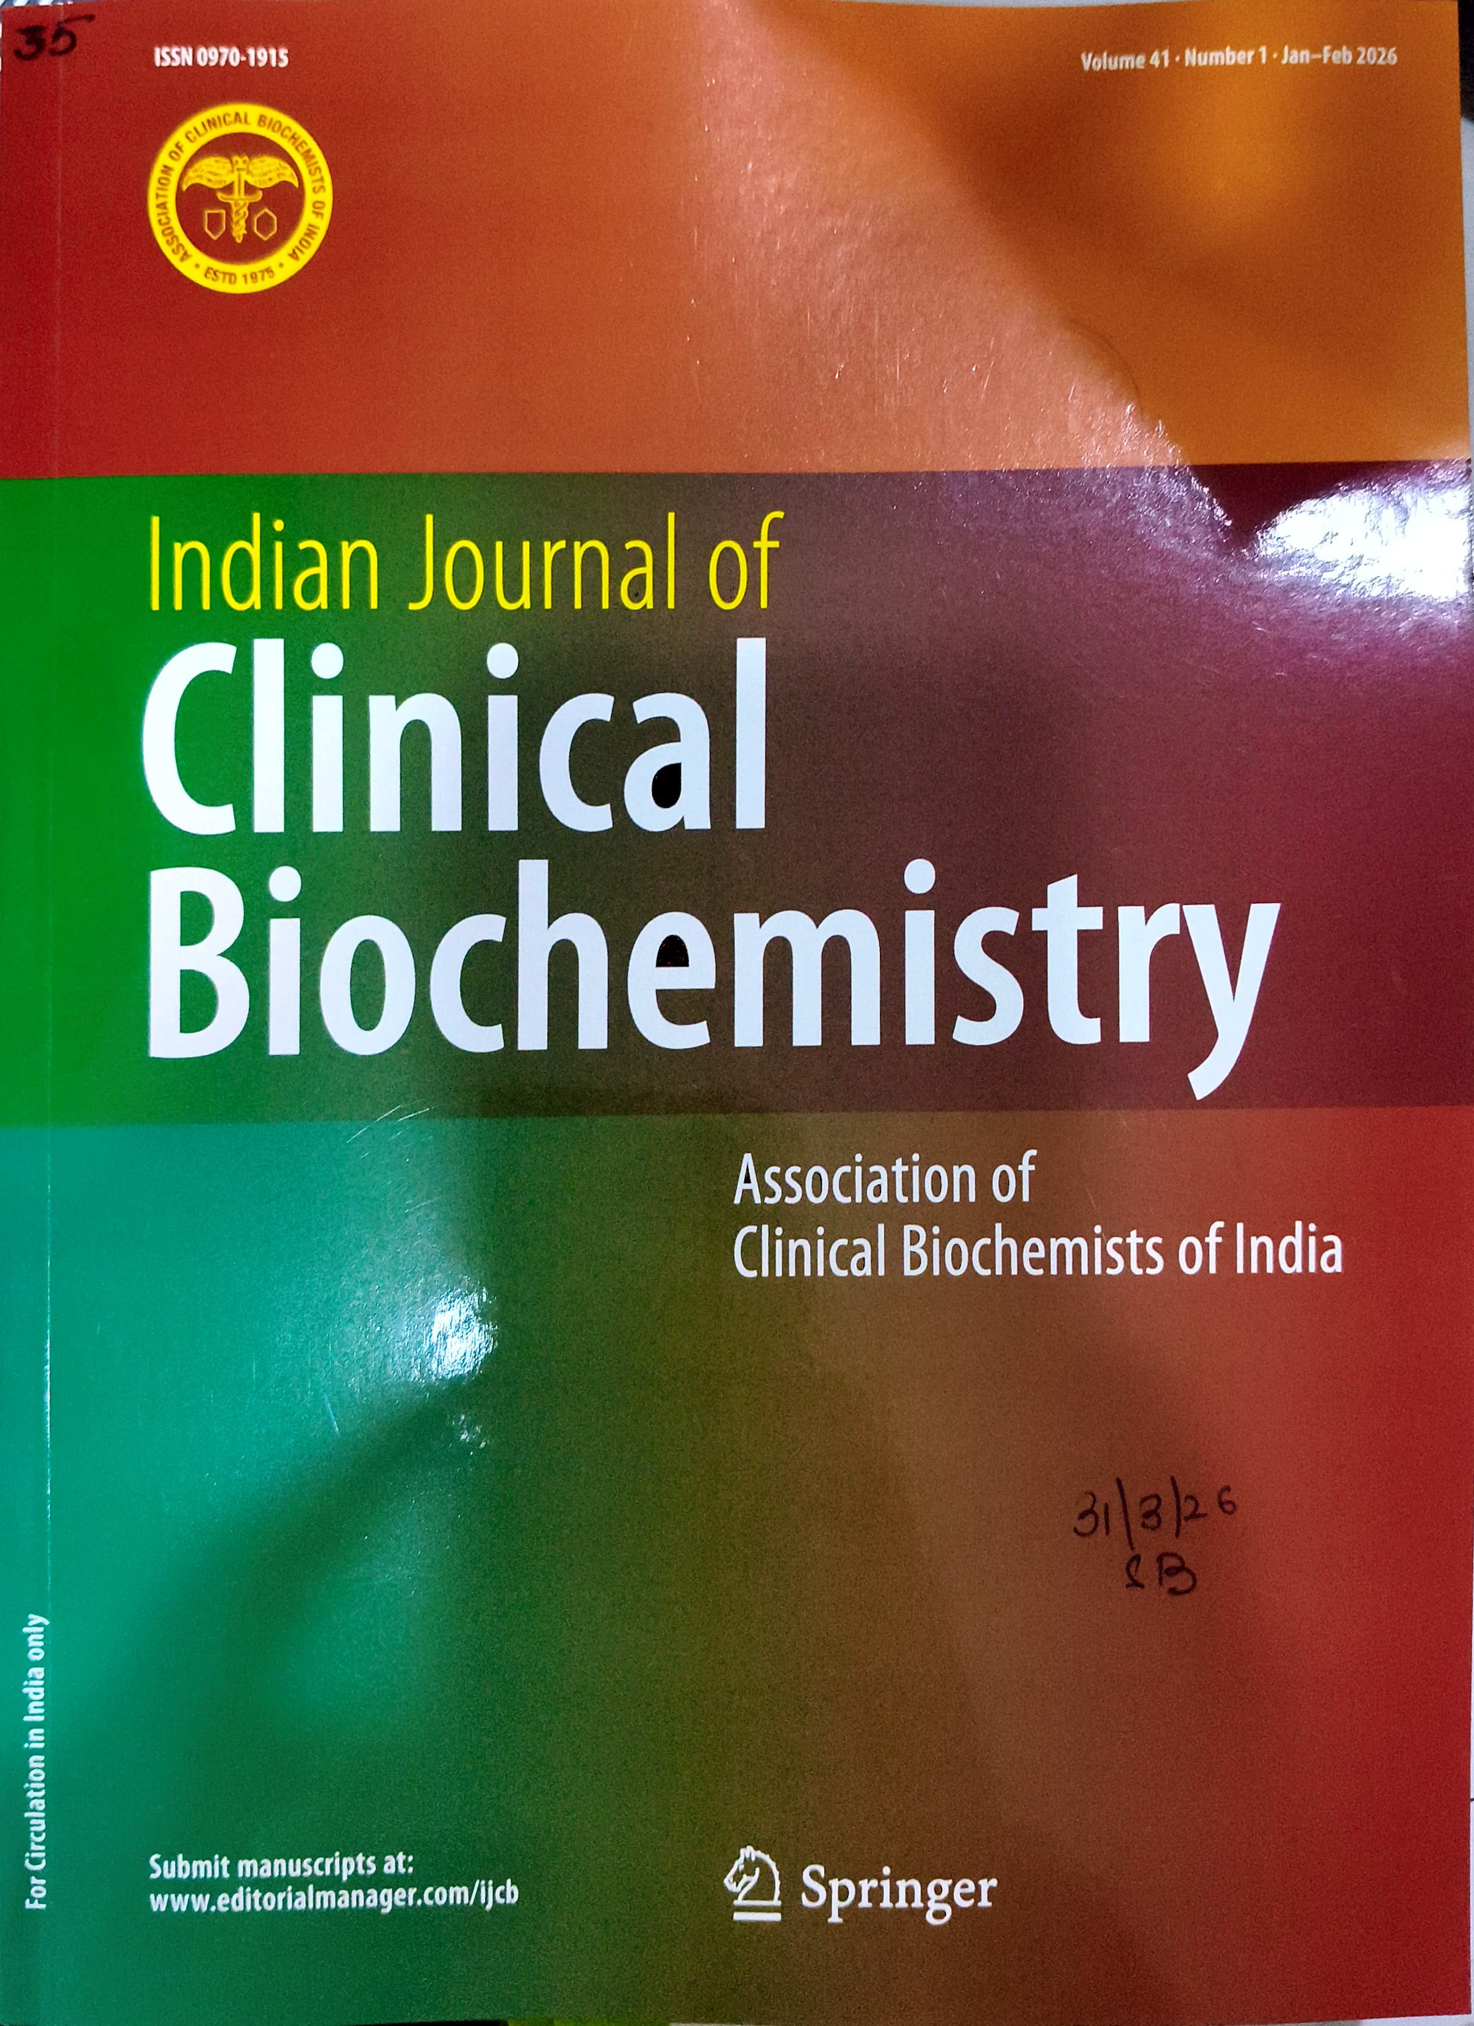



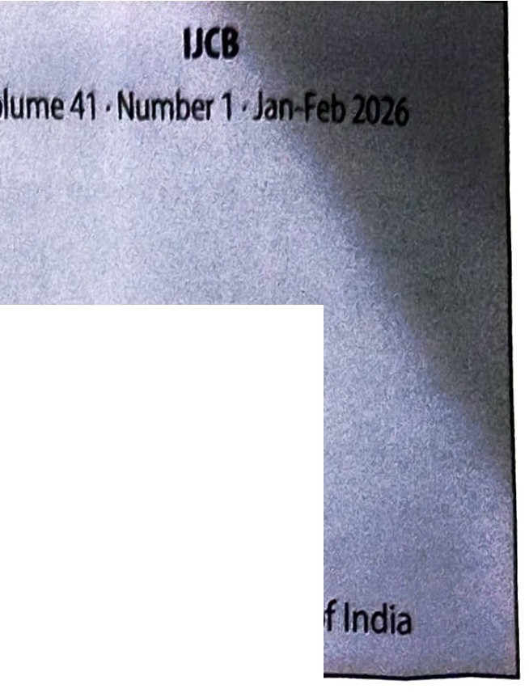
EDITORIAL
ISSN 0970-1915
12291
Indian Journal of
Clinical Biochemistry
Official Journal of the Association of Clinical Biochemists
AI, Automation and the Future Role of the Clinical Biochemist: from Analyzer Custodian to Clinical Knowledge Partner
P. Mitra • S. Gupta· P. Shanna 1

REVIEW ARTICLES
Exploring the Interplay Between Micronutrients and Cytokine Storm in Children with Multisystem Inflammatory Syndrome: 'A Potential Mechanical Insight'
L. Elizabeth · B. Shanthi • C. Cherupanakkal • J.J. Joseph •
A. Anirudhan • K. Vaidyanathan 5
Whether Dye-Based Methods Are Ready for Microalbuminuria Detection: A Review of Research in the Field
M. Kumari • D. Kumar • R. Bhattacharyya •
D. Banerjee 17
Programmed Cell Death and its Implications for Skeletal Muscle Wasting
R. Dabur • A. Yadav 31
The Paradigms and Paradoxes of Sigma Metrics in the Analytical Phase of the Medical Diagnostic Laboratory
S. Bhargava 42
The Pathogenesis of Rheumatic Heart Disease with Unsettled Issues
S. Sharma· U. Sharma 50
ORIGINAL RESEARCH ARTICLES
Differential Expression of Circulating miR-221-3p, miR-146a-5p, miR-206 and Their Diagnostic Value in Lung Cancer
J.A. Wani • S. Majid • N.N. Shah· A.A. waza •
M.Y. Rather· H. shafi 62
Association of Interleukins 17A and 17F Gene Polymorphism with Asthma: A Case Control Study in North Indian Population
R. Pandey· V. Prakash 74
Hesperidin Supplementation During Alternate Day Fasting Provides Synergistic Effect in Conferring Neuroprotection to Aging Rats
S. Bhoumik • R. Kesherwani • S.I. Rizvi 85
Hypertensive Pregnancy Supports Higher Adaptation of Stress Over Anemic Pregnancy: A Pilot Study
V. Rastogi· N. Kaushik • A.K. Singhal • B. Yadav.
A. Narayan • N.C. Chandra 95
LENG8-AS1: A Prognostic Biomarker in Colorectal Cancer-Differential Expression and Clinical Implications
P. Jafamia • M. Mahdevar • M. Peymani 105
Development of a Robust, Rapid and Reliable Tandem Mass Spectrometry Method for the Measurement of Sildenafil, Bosentan and their Major Metabolites
M.A. Bik • D.E. Onmaz • K.M.K. Gharab • F. Karaman •
S. Abusoglu • A. Sivrikaya • A. Unlu 113

