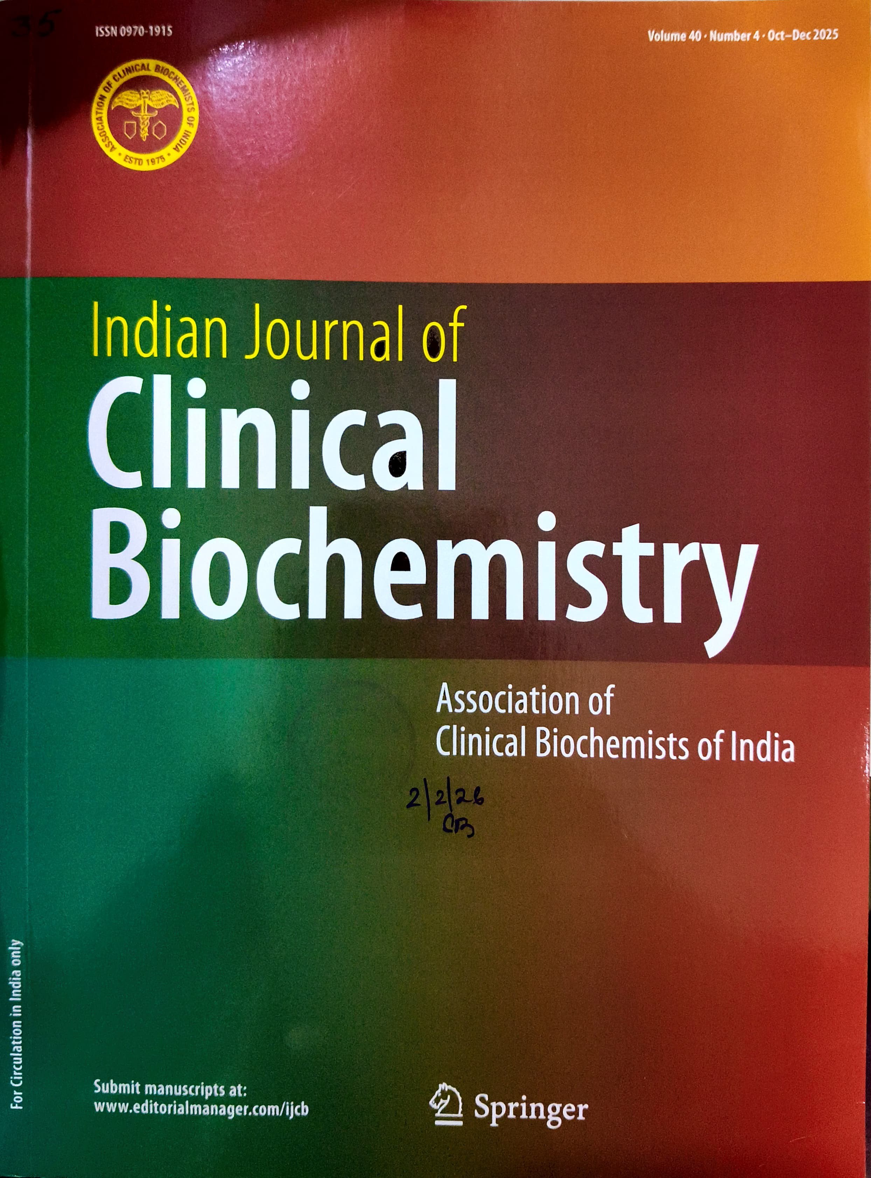

I


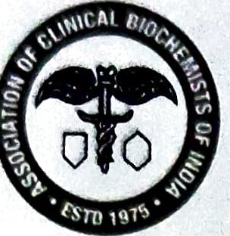


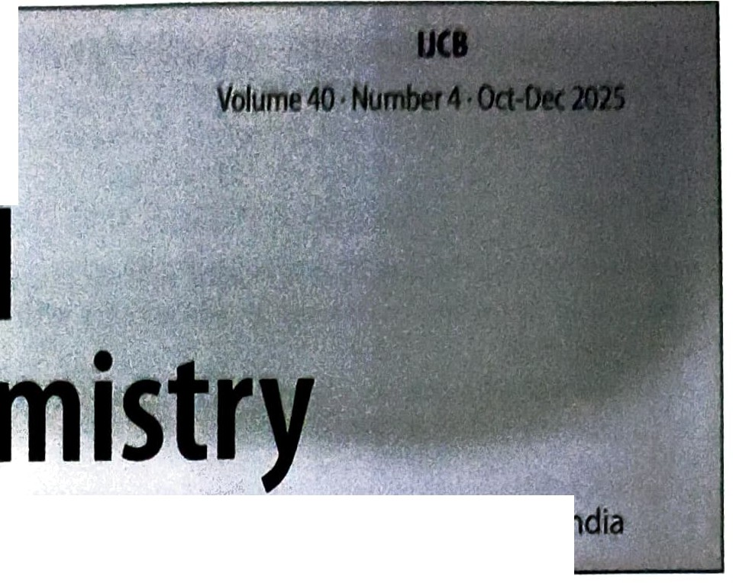
EDITORIAL
Clinh:a
lndian Journal-of
1229'1
Bioche
Official Journal of th!:! Association of Clinical Biochemrsts ofl
Advanced Antioxidant Science is Reshaping the Battle Against Metabolic Syndrome: Next-Generation Approaches to Unlock Oxidative Stress Solutions
D. Yadav • M. K.hokhar · P. Sharma 519

REVIEW ARTICLES
Role of Fruit-Derived Antioxidants in Fighting Cancer:

A Narrative Review
Y.F. Mustafa 522

Unveiling Hydrogen Sulfide: A New Frontier in Neuroprotection and Neuromodulation
G. Fatima · A.A. Mahdi • H.B. Alhmadi •
0. Medvedev 540
A Review of Methionine and Cysteine: Their Roles as Sinks for Reactive Oxygen and Nitrogen Species, Including Bioinformatic Analysis of Their Percent Compositions in Metabolic Proteins
B.F. Laatsch• B.A. Ali· A.R. Berthiaume·
G.C. Cunningham • S.M. Duncan • N. Hau • A. Ho •
M.A. Loomis • H.R. Lowater • B.L. McNally •
K.L. Mueller• M. Poppitz • S.A. Prickett· S.E. Schroeder·
M.L. Shepler · B.H. Shoberg • C.G. Shult • L.S. Smith •
K.L. Snyder • J.E. Steczynski • A. Torti • A. Yoon •
M.M. Weiss·T.B. Wilson· S. Bhattacharyya •
S. Hati 551

ORIGINAL RESEARCH ARTICLES
The Effects of Alpha Linolenic Acid (Omega-3 Fatty Acid) on Tobacco Craving Intensity, Withdrawal Symptoms and Biochemical Markers in Tobacco Users
A. Singh • N. Verma•S. Kant • A.K. Verma • A. Tripathi •
K. Bhardwaj 563
Genetic Variants of AGO1*rs595961 and AGO2"'rs4961280 with Susceptibility to Bladder Carcinoma
R.M. Elshazli · H.M. Kassab • A.F. Salama •
K.M. Okasha 576
Ellagic Acid Displays a Protective Effect on Red Blood Cell Membrane During Aging in Humans
Deepika • T.C. Dakal · Richa · P.K. Maurya 588
Advancing NSCLC Diagnosis: The Role of Tumor-Derived Serum Exosomal SNORD60 as a Novel Biomarker
L. Li· K. Wang· N.Yuan· Q. Zhang· X. Liang·
Z. Zhang 599
The IKAROS Transcription Factor Gene IKZFl as a Critical Regulator in the Pathogenesis of Childhood Acute Lymphoblastic Leukemia: Insights from a Bangladeshi Population
N.N. Nila· S. Tamanna • Z. Mahmud • M. Washif •
T. Ahmad· A.T.M.A. Rahman· Md.Z.H. Howlader 610
Predictive Value of Lymphocyte Based Indices to Determine Major Adverse Cardiovascular Events in Acute Coronary Syndrome Undergoing Percutaneous Coronary Intervention
V. Mohanty · S. Deoni • A. Kaushik · R. Choudhary ·
D. Yadav · K. Singh 619
Exploring the Role of Serum Lysyl Oxidase (LOX) Levels and LOX Gene Polymorphism (G473A) in Diabetic Nephropathy
D. Gayathri Devi· M. Mangaraj · S.K. Panda·S. Kumari •
G.K. Saharia 628

. . markers for Diagnosis of Acute Utility of Urinary io. VID-19
8
. . I ·ury (AKI) m CO . Kidney I\J R Ramachandran • V. MahaJan • T Samra . V Kumar • • . .
•

. • D Pu •.A Bhalla. A. Pal· R. D1x1t •
N.B. Nruk • G. • n •
P. Kaur 636

Plasma-Derived Exosom 1
tRF-Gly-GCC-037as No:e:!!·Phe·GAA.ooi Cervical Cancer •agnosticBiorn and Z• L. arke
1 • H. Wang . R. Yang .X 1.
P. Ge 683 • Jn•Q•H Z.She.
an •

AnaIys.is of Specific Serum Markers for Early .


Prediction of Alzheimer's Disease in Adolescents with
Down Syndrome

N.A.Meguid . M. Hemimi • G. Elpatrik • E.A. Fouad-Elhady •
A.A Dardir • H.H. Ahmed 644

Global DNA Methylation and Cognitive Impairment:
A Population-Based Study from Haryana, North India
K. Khate • V. Chaudhary • D. Bhattacharjee • A. Kaushik •
G.K.Walia • N. Babu • K.N. Saraswathy • N.K. Devi 651

Crosstalk Between Long Non-coding RNA MALATl, miRNA-181a, and IL-17 in Cirrhotic Patients and Their Possible Correlation SIRTl/NF-1etJ Axis
S.E. Khalaf· S.N. Abdelfattah • N.A. Hasona 660

Upregulation of SLC25A32 in Tumorous Tissues of Patients with Non-Metastatic Colorectal Cancer: A Pilot Study
M. Hashemi • M. Tahmasebi-Birgani • A. Talaiezadeh •
A. Saberi 668

Low Vitamin A Status: A Potential Limiting Factor for Hemoglobin Improvement to Iron-Folic Acid Supplementation in Adolescent Girls with Iron Deficiency Anemia
S.Dantbam • I. Gaddam • S.S. Vadakattu • N. Boini .
R.R. Chowdavarapu 676

Further articles can be found at http://link . joumaVl 2291 .spnnger.com1

lndexed/abstra�ted in PubMed, PubMedCentralS, C0PUS EMBASE. , Chem.ical Abstr.acts.Service (CA,S) Googl eScho/a

Academic OneFile, Elsevier Bzobase, ExpandedAcadem· •
. d' S . 1c,l
C 1

opernicus, n ian cience Abstracts, IndMed, /N/SAtomin
Medlnd, OCLC, PubMed (12 months embargo), SC!mago, Summon by Serial Solutions, Zoological Record

Instructions for Authors for Ind J Clin Biochemare available at http://www.springer.com/1ife+sciences/ biochemistry+%26+biophysics/journa1/12291

Compliance with Ethical Requirements
Indian Journal of Clinical Biochemistry requests that all auth comply with Springer's ethical policies. To view our ethics statements please visit the following:
- Conflict of Interest and Ethical Standards: http://www.sprine,oer.
authors?SGWID=0-111-6-791531-0
- Informed Consent: http://www.springer.com/authors?
SGWID=0-111-6-608209-0
Statement of Human and Animal Rights: http://www.sprioger.co
authors?SGWID=0-111-6-608309-0

