B.TECH/CSE/8TH SEM/CSEN 4244/2019

PATTERN RECOGNITION
(CSEN 4244)

Time Allotted : 3 hrs Full Marks : 70

Figures out of the right margin indicate full marks.

Candidates are required to answer Group A and
any 5 (five) from Group B to E, taking at least one from each group.

Candidates are required to give answer in their own words as far as practicable.

Group – A
(Multiple Choice Type Questions)

1. Choose the correct alternative for the following: 10 × 1 = 10

(i) Which among the following statements best describes our approach to learning decision trees?
(a) Identify the best partition of the input space and response per partition to minimize sum of squared error.
(b) Identify the best approximation of the above by the greedy approach (for identifying the partitions).
(c) Identify the model which gives the best performance using the greedy approximation with the smallest partition scheme.
(d) Identify the model which gives performance close to the best greedy approximation performance with the smallest partition scheme.

(ii) How may Boolean functions can we design with two inputs?
(a) 8 (b) 4 (c) 16 (d) 32.

(iii) In gradient descent rule, the direction (u) that we intend to move in should be at _______ degree with respect to the gradient.
(a) 45 (b) 180 (c) 90 (d) 135.

(iv) Assume that in a training dataset the number of features is five. In order to select three features from the feature set, the number of feature subsets to be searched by Sequential Forward Selection algorithm is
(a) 7 (b) 9 (c) 8 (d)10.
(v) Which of the following is NOT true for Bayes model for classification?
(a) Predictors should be categorical
(b) Numerical values need not be converted into categorical
(c) Naive Bayes classifiers are highly scalable
(d) All the records are used instead of relying on just the matching records.

(vi) Match between the terminologies of Genetic Algorithms and Genetic.

Genetic Algorithm | Genetics
(1)representation structure | (i) external disturbance, such as cosmic radiation.
(2) crossover | (ii) chromosomes
(3) mutation | (iii) survivability
(4) selection | (iv) sexual reproduction
(a) 1- ii, 2- iv, 3- i, 4- iii (b) 1- iii, 2- iv, 3- i, 4- ii
(c) 1- ii, 2- i, 3- iv, 4- iii (d) 1- iii, 2- iv, 3- ii, 4- i.
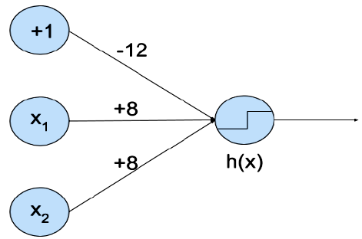
(vii) You are given the following neural network that takes two binary valued inputs x₁,x₂∈{0,1} and the activation function is the threshold function (h(x) = 1, if x > 0; 0, otherwise). Which of the following logical functions does it compute?

(a) OR (b) AND (c) NAND (d) none of the above.
(viii) Considering single-linkage and complete-linkage hierarchical clustering, is it possible for a point to be closer to points in other clusters than to points in its own cluster? If so, in which approach will this tend to be observed?
(a) No
(b) Yes, single-linkage clustering
(c) Yes, complete-linkage clustering
(d) Yes, both single-linkage and complete-linkage clustering.

(ix) What should be the best choice for number of clusters based on the following results (as shown in the following figure):
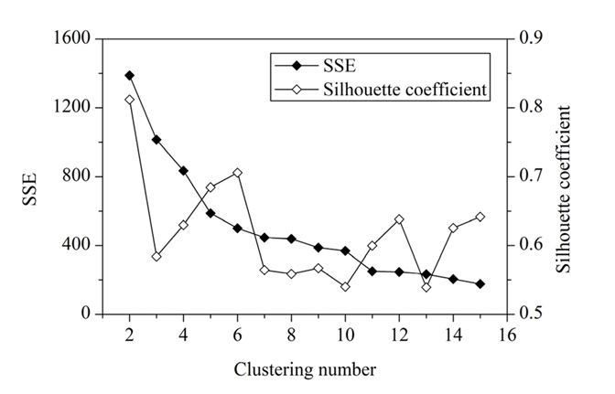
(a) 2 (b) 4 (c) 6 (d) 8.

(x) Which of the following is/ are the pre-requisite(s) when genetic algorithm is applied to solve problems?
(I) Encoding of solutions
(II) Well-understood search space
(III) Method of evaluating the suitability of the solutions
(IV) Containing only optimal solution
(a) I and II (b) II and III (c) I and III (d) III and IV

Group – B

2 . (a) Suppose, we have two cigar like clusters in two dimensions, one cigar has y=1 and the other y=-1. The cigars are positioned in parallel and very closely together such that the variance in the total dataset, ignoring the labels is in the direction of cigars.
- Would the above projection be useful for classification? Explain with proper justification.
- How do we utilize the label information in finding informative projections? Discuss the method briefly.

(b) Given some data in R³ with the corresponding 3 × 3 second-moment matrix C with eigen vectors C_{α} and eigen values λ_{α} with λ₁=2, λ₂=1, λ₃=0.2.
- Define a matrix A∈R^{2×3} that maps the data into a two-dimensional space while preserving as much as variance possible.
- Define a matrix B∈R^{3×2} that places the reduced data back into R³ with minimal reconstruction error. How large is the reconstruction error?
- Prove that AB is an identity matrix.
(2+6) + (1+2+1) = 12

3. (a) Consider the two-dimensional patterns: {(1, 1)^{t} , (1, 2)^{t} , (4, 4)^{t} , (5, 4)^{t}}. Obtain the sample covariance matrix, its eigenvalues and eigenvectors.

(b) Is Fisher's Linear Discriminant Analysis supervised? Justify your answer.

(c) Consider two vectors X and Y where X = (50, 2, 29, 62, 140) and Y = (55, 15, 50, 70, 170). Obtain the k-Median distance where k = 3.

7 + (1 + 2) + 2 = 12

Group – C

4. (a) Suppose, we have two sets P and N of points in an n-dimensional space that are linearly separable. If the vectors in P and N are tested cyclically one after the other, prove that a weight vector w_{t} will be found after a finite number of steps (t) which can separate the two sets.

(b) Show that a single-layer perceptron cannot implement the XOR logic gate.
8 + 4 = 12

5. (a) Suppose, you are stranded on a deserted island. Mushrooms of various types grow widely all over the island, but no other food is anywhere to be found. Some of the mushrooms have been identified by as poisonous and others as not. You are the only one remaining on the island. Please consider the data in which you know whether or not mushrooms M1 through M8 are poisonous, but you do not know about mushroom M10. Draw a decision tree for the given training data using ID3 algorithm. Consider the attributes named Not Heavy, Smelly, Spotted, Smooth, Edible (as target class) to construct the decision tree. Now, classify mushroom M10 using your decision tree.

Example | Not Heavy | Smelly | Spotted | Smooth | Edible
M1 | 1 | 0 | 0 | 0 | 1
M2 | 1 | 0 | 1 | 0 | 1
M3 | 0 | 1 | 0 | 1 | 1
M4 | 0 | 0 | 0 | 1 | 0
M5 | 1 | 1 | 1 | 0 | 0
M6 | 1 | 0 | 1 | 1 | 0
M7 | 1 | 0 | 0 | 1 | 0
M8 | 0 | 1 | 0 | 0 | 0
M10 | 0 | 1 | 1 | 1 | ?

(b) What would happen if we try to consider the attribute named Example to construct the decision tree using ID3 algorithm?

(c) What are the properties of Bayes classifier? Explain them briefly.

(6 + 1) + 2 + 3= 12

Group – D

6. (a) Suppose, you are given a database of five documents- A, B, C, D and E. The following table represents the inter document proximity matrix. Draw step by step working of an agglomerative hierarchical clustering algorithm using MIN and draw the dendrogram.

Document | A | B | C | D | E
A | 0 | 1 | 2 | 2 | 3
B | 1 | 0 | 2 | 4 | 3
C | 2 | 2 | 0 | 1 | 5
D | 2 | 4 | 1 | 0 | 3
E | 3 | 3 | 5 | 3 | 0

(b) Is the above algorithm greedy or not? Justify your answer.

(c) How does k-means clustering algorithm differ from fuzzy c-means clustering algorithm?
6 + 2 + 4 = 12

7. (a) The following table contains the pairwise distances for the five objects (A, B, C, D, E). Use minimum spanning tree based divisive hierarchical clustering algorithm to cluster the objects into three clusters.
Object | A | B | C | D | E
A | 0 | 1 | 2 | 2 | 3
B | 1 | 0 | 2 | 4 | 3
C | 2 | 2 | 0 | 1 | 5
D | 2 | 4 | 1 | 0 | 3
E | 3 | 3 | 5 | 3 | 0

- Which one of the two hierarchical clustering algorithms i.e. single-linkage and complete-linkage is robust to outliers? Justify your answer.

- Define a core point in DBSCAN algorithm. Suppose, we run DBSCAN algorithm with minpoints = 6 and epsilon = 0.1 for a dataset and we obtain four clusters and 5% of the objects are classified as outliers. Now, we run the same algorithm with minpoints = 8 and epsilon = 0.1. How do we expect the clustering results to change?
5 + (1 + 2) + (2 + 2) = 12

8. (a) Define AND-fuzzy neuron and OR-fuzzy neuron.

(b) Consider the following rules:
if x is SMALL and y is BIG, then o=x-y
if x is BIG and y is SMALL, then o=x+y
if x is BIG and y is BIG, then o=x+2y
where the membership functions of SMALL and BIG are defined by
SMALL(v)={1, if v < 1; 1-((v-1)/4), if 1<=v<=5; 0, otherwise}
BIG(u)={1, if u>5; 1-((5-u)/4), if 1<=u<=5; 0, otherwise}
Suppose we have the inputs x₀=3, y₀=3. Find the output of the system using Sugeno’s reasoning method.
(c) Construct ANFIS architecture for Sugeno’s reasoning method.
(2 + 2) + 4 + 4 = 12

9.(a) Which two requirements should a problem satisfy in order to be suitable for solving it by genetic algorithm?

(b) Describe the genetic operators used in genetic algorithm?

(c) What is meant by the term Elitism in genetic algorithm?

(d) Suppose, we want to implement genetic algorithm based ANFIS. Which chromosome could represent an individual in this algorithm? Suggest a fitness function for this problem.
2+ 4 + 2 + (2 + 2) = 12

