**B.TECH/EE/5TH SEM/ELEC 3102/2018**

**POWER SYSTEM-I**

**(ELEC 3102)**

**Time Allotted : 3 hrs Full Marks : 70**

***Figures out of the right margin indicate full marks.***

***Candidates are required to answer Group A and***

***any 5 (five) from Group B to E, taking at least one from each group.***

***Candidates are required to give answer in their own words as far as practicable.***

**Group – A**

**(Multiple Choice Type Questions)**

1. Choose the correct alternative for the following: **10 × 1 = 10**

(i) Sheaths are used in cables to

(a) provide proper insulation (b) protect the cable from moisture

(c) provide mechanical strength (d) None of the above.

(ii) ACSR conductor stands for

(a) Alloy Copper Steel Reinforced

(b) Aluminium conductor Steel Reinforced

(c) All copper Steel Reinforced

(d) Aluminium Copper Steel Reinforced.

(iii) Pulverised coal is

(a) non-smoking coal (b) coal free from ash

(c) coal which burns for long time (d) coal broken in fine particles.

(iv) Feeder is designed mainly from the point of view of

(a) current carrying capacity (b) voltage drop in it

(c) operating voltage (d) operating frequency.

(v) What is the shape that is attained by the conductors if suspended from the same height?

(a) Parabola (b) Catenary (c) Semi- circle (d) Straight.

(vi) Transposition of the transmission line is done to

(a) reduce line loss (b) reduce skin effect

(c) balance line voltage drop (d) reduce corona.

(vii) Bad weather conditions such as rain and sleet

(a) increase the corona loss

(b) decrease the corona loss

(c) does not affect the corona loss

(d) sometimes increase and sometimes decrease.

(viii) Demand factor is defined as the ratio of

(a) average load to maximum demand

(b) maximum demand to connected load

(c) connected load to maximum demand

(d) maximum demand to average load.

(ix) The stringing chart is useful in

(a) finding the length of the conductor

(b) the design of tower

(c) the design of insulator string

(d) finding the sag in the conductor.

(x) In a long transmission line, the propagation constant is

(a) $\sqrt{(z+y)}$ (b) $\frac{z}{y}$ (c) $\sqrt{\frac{z}{y}}$ (d) $\sqrt{zy.}$

Where the symbols have their usual meaning.

**Group – B**

2. Draw and explain the schematic layout of a thermal power station.

**6 + 6 = 12**

3. (a) Explain the working principle of nuclear reactor with appropriate diagram.

(b) A steam power plant spends Rs.60 lacs per annum for coal used in the plant. The coal has a calorific value of 5000 Kcal/Kg and costs Rs. 3000 Per ton. Overall efficiency of the plant is 30%. Find the average load of the plant.

(c) What for dam is provided in hydroelectric power station?

**5+ 5 + 2 = 12**

**Group – C**

4. (a) Explain the method of images for the calculation of capacitance of a single- phase transmission line.

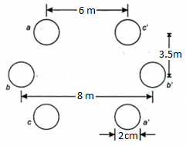

(b) Calculate the Inductance per phase of a three-phase double-circuit line as shown in Figure 1. The diameter of the conductor is 2 cm. Assume that the line is completely transposed.

**Figure 1**

**6 + 6 = 12**

5. (a) Derive the expression for dielectric stress in a single core cable. Where is the potential gradient maximum in a single-core cable and why?

(b) A single core cable 2 km long has a core diameter of 1.8 cm and the diameter of the inside sheath is 4 cm. The relative permittivity of the insulating material is 4. The power factor of the circuit is 0.07 and the supply voltage is 11 kV, three phase, 50 Hz. Determine (i) the capacitance of the cable, (ii) the charging current per conductor and (iii) dielectric loss.

**(4 + 2) + 6 = 12**

**Group – D**

6.(a) Explain the methods of improving string efficiency.

(b) A string of 4 insulators has self capacitance equal to 3 times the pin to earth capacitance. Calculate: (i) the voltage distribution across various units as a percentage of total voltage across the string and (ii) string efficiency.

(c) What is safety factor of insulators?

**5+ 6 + 1 = 12**

7.(a) What are the factors on which corona loss depends?

(b) A 3-phase overhead transmission line consists of 30 mm diameter conductors arranged in the form of an equilateral triangle. Assume the temperature 35°C, atmospheric pressure 74 cm, irregularity factor 0.93 and breakdown strength of air 30 kV per cm (peak). Find the minimum spacing between conductors, if the disruptive critical voltage is not to exceed 220 kV between the lines.

(c) An overhead line has a span of 180 meters between level supports. The conductor has a cross sectional area of 1.22 cm2 and weighs 1.12 kg/meter and has a breaking stress of 4150 kg/cm2. Allowing a wind pressure of 110 kg/m2, calculate the slant sag for a factor of safety of 4.

**4 + 4 + 4 = 12**

**Group – E**

8.(a) What are the effects of low power factor?

(b) What is three-part tariff?

(c) A two wire D.C. distributor AB is fed from both ends. At the feeding point A the voltage is maintained at 240 V and at B 250 V. The total length of the distributor is 200 meters and loads are tapped off as under:

25A at 50 meters from A; 50A at 75 meters from A; 30 A at 100 meters from A; 40A at 150 meters from A. If the resistance per km of conductors (both go and return) is 0.6Ω, calculate:

1. the currents in the various sections of the distributor,
2. the minimum voltage and the point at which it occurs,

**4+ 2 + 6 = 12**

9. (a) What do you mean by Ferranti effect? Explain with proper phasor diagram.

(b) A 3-phase 50 Hz transmission line(as shown in Figure 2) has resistance, inductance and capacitance per phase of 10 Ω, 0.1 H and 0.9 µF and delivers a load of 35 MW at 132 kV and 0.8 power factor lagging. Determine the efficiency and regulation of the line using nominal-T network.

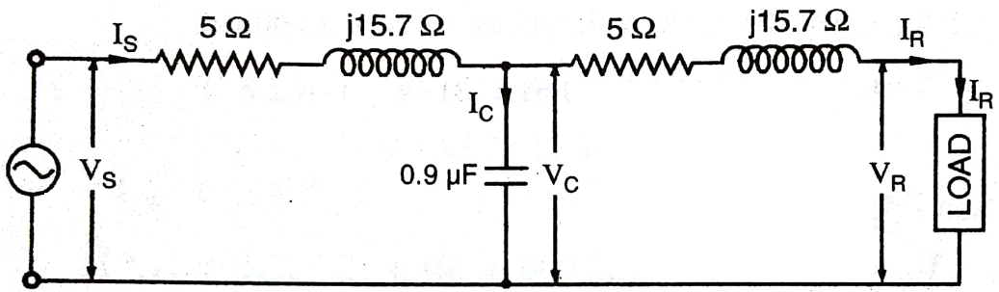

**Figure 2**

**(1 + 3) + 8 = 12**