**B.TECH/CSE/6TH SEM/CSEN 3281/2018**

**ARTIFICIAL INTELLIGENCE**

**(CSEN 3281)**

**Time Allotted : 3 hrs Full Marks : 70**

***Figures out of the right margin indicate full marks.***

***Candidates are required to answer Group A and***

***any 5 (five) from Group B to E, taking at least one from each group.***

***Candidates are required to give answer in their own words as far as practicable.***

**Group – A**

**(Multiple Choice Type Questions)**

1. Choose the correct alternative for the following: **10 × 1 = 10**

(i) Which of the following search strategy is also called as blind search?

(a) Uninformed search (b) Informed search

(c) Simple reflex search (d) All of the above.

(ii) Which of the following search methods is equal to MINIMAX search but eliminates the branches that can’t influence the final decision?

(a) DFS (b) BFS

(c) Alpha-beta pruning (d) None of the mentioned.

(iii) Where does the value of alpha-beta search get updated?

(a) Along the path of search (b) Initial state itself

(c) At the end (d) None of the mentioned.

(iv) A perceptron is

(a) a single layer feed-forward neural network with pre-processing

(b) an auto-associative neural network

(c) a double layer auto-associative neural network

(d) a neural network that contains feedback.

(v) When is breadth-first-search optimal?

(a) When there is less number of nodes

(b) When all step costs are equal

(c) When all step costs are unequal

(d) Both (a) & (c).

(vi) Consider the following PROLOG clauses:

p(1). p(2):-!. p(3).

Which of the following is correct if the goal p(X), !, p(Y) is placed?

(a) X=1, Y=1 (b) X=1, Y=1; X=1, Y=2

(c) X=2, Y=1 (d) all of the above.

(vii) Which is true?

(a) Not all formal languages are context-free

(b) All formal languages are Context free

(c) All formal languages are like natural language

(d) Natural languages are context-oriented free.

(viii) The initial state and the legal moves for each side define the ________ for the game.

(a) search tree (b) game tree

(c) state space search (d) forest.

(ix) Which value is assigned to alpha and beta in the alpha-beta pruning?

(a) Alpha = max (b)Beta = min

(c) Beta = max (d) Both Alpha = max & Beta = min.

(x) In Bayes theorem, what is the meant by P(X|Y)?

(a) The probability that hypotheses X is true given evidence Y

(b) The probability that hypotheses X is false given evidence Y

(c) The probability that hypotheses X is true given false evidence Y

(d) The probability that hypotheses X is false given false evidence Y

**Group – B**

2. (a) We have 3 jugs of capacities 3, 5, and 8 litres respectively. There is no scale on the jugs, so it's only their capacities that we certainly know. Initially, the 8-litre jug is full of water, the other two are empty.

Now answer the following questions:

(i) Formulate this problem as state-space search problem by clearly representing the initial state, set of goal states and possible operators.

(ii) Draw the state-space graph for the problem.

(iii) Show any one solution to the problem by specifying the sequence of operators.

(b) “Chaining is a special case of resolution” - Justify the statement for propositions with suitable example.

**(3+ 4 + 3) + 2 = 12**

3. (a) Consider the following set of propositional sentences:

1. The-humidity-is-high ∨ the-sky-is-cloudy.

2. If the-sky-is-cloudy then it-will-rain

3. If the-humidity-is-high then it-is-hot.

4. it-is-not-hot

Now, Prove by resolution theorem on propositions that “it-will-rain”

(b) Prove that for a branching factor of 10 & deep goals, iterative-deepening search expand only about 11% more nodes than a breadth-first search expands.

**6 + 6 = 12**

**Group – C**

4.(a) Consider the following 2 player game tree in which static scores are given from the first player’s point of view:



Suppose the first player is the maximizing player. What move should be chosen? Why? Use Mini-Max search to solve. Also explain limitations of Mini-Max search. How to overcome them?

(b) Solve the following Crypt-arithmetic problem with the following constraints. Give solution steps.

Constraints: (i) Use decimal arithmetic and

(ii) No two letters possess same digit.

C R O S S

+ R O A D S

D A N G E R

**7 + 5=12**

5. (a) What do you mean by Constraint Satisfaction Problem?

(b) Let’s consider the following graph with 6 vertices. The job is to color the vertices of the graph properly by using only three colors red, blue & green.



Now answer the following questions:

i) Formulate the problem as a CSP by clearly mentioning the set of variables, domain of each variable and a set of constraints. Draw the constraint graph for the problem after completing the formulation.

ii) Apply Backtracking method to find one solution of the problem. You select variables as per the decreasing order of the number of constraints the variables have.

(c) Prove that the heuristic ‘sum of manhattan distances’ for the 8-puzzle problem used by A* algorithm is an admissible heuristic.

**1 + (3 + 3) + 5 = 12**

**Group – D**

6. (a) Consider the following FOPL sentences:

i) ∀X: Barks (X) → Dog (X).

ii) ∀X∀Y∃Z: Has-master (X, Y) ∧ Likes (X, Y) ∧ Unprecedented_situation

(Z) → Barks (X)

iii) Unprecedented-situation (noise).

iv) Likes (fido, jim).

v) Has-master (fido, jim).

Now using resolution method prove that Dog (fido) can be inferred from the above sentences.

(b) Write a program in PROLOG to reverse a list using accumulator.

**7 + 5 = 12**

7. (a) Consider the following Bayesian Network containing 3 Boolean random variables:

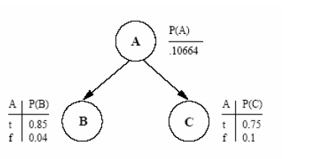

Compute the following quantities:

(i) p(~B, C | A) (ii) p(A | ~B, C)

(b) Draw a semantic network representing the following sentences:

i) Emus are birds

ii) Typically birds fly and have wings

iii) Emus can run

**6 + 6 = 12**

**Group – E**

8. (a) Discuss the importance of mutation operation in the implementation of genetic algorithm and its convergence.

(b) Explain how Artificial Neural Network can be used as a classifier.

**5 + 7 = 12**

9. (a) Create a decision tree by using the given dataset that describes which day is suitable for playing Tennis. Here, the days are described by the attributes like outlook, temperature, humidity & wind. Use entropy as the impurity measure while creating the Decision Tree.

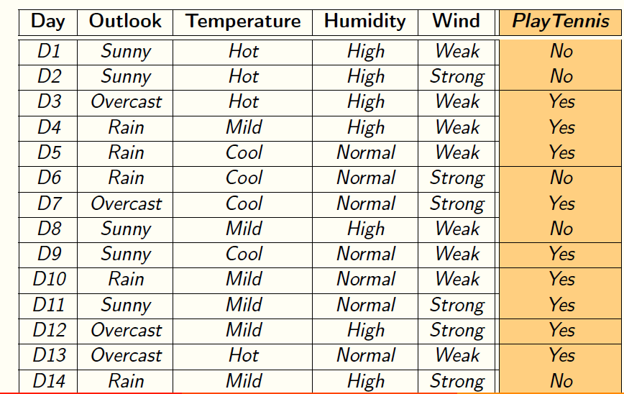

(b) Identify the drawbacks of Roulette Wheel selection method used in Genetic Algorithm.

**10 + 2 = 12**